ДЗ 11

установка android studio

ознакомление с androidstudio

подключение android studio к github

visual studio code

Выполнение скриншоты:

AS Installed

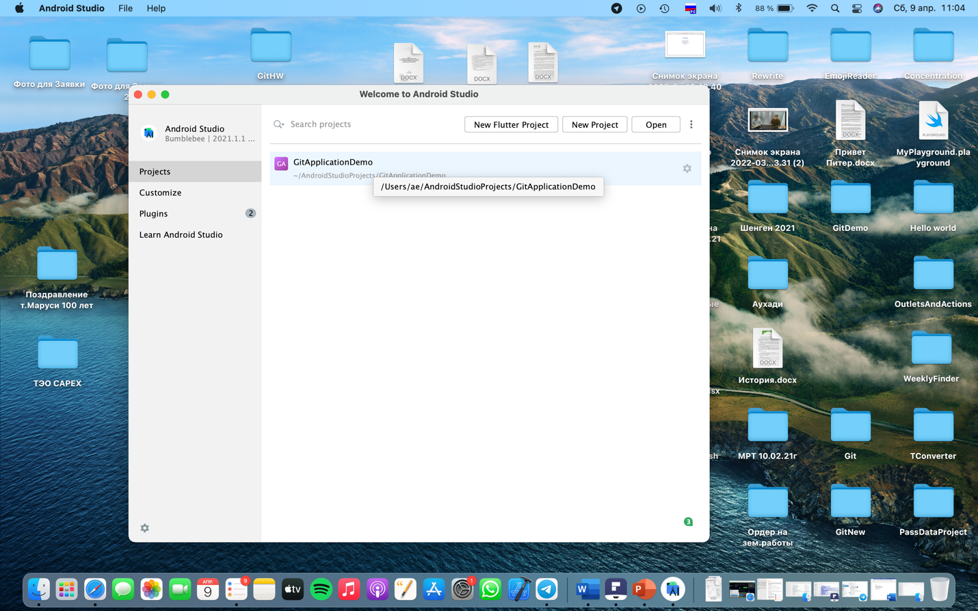

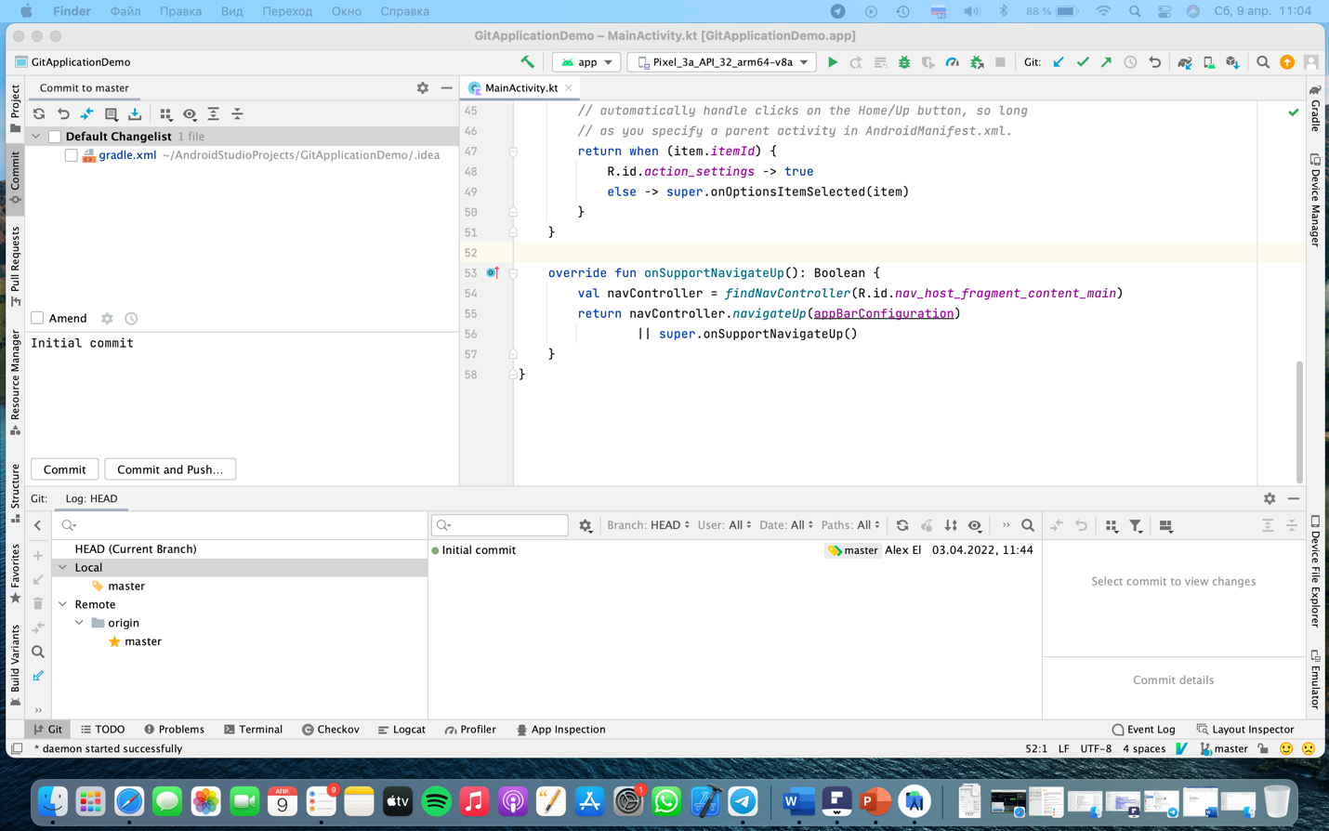

GitGub and AS binded

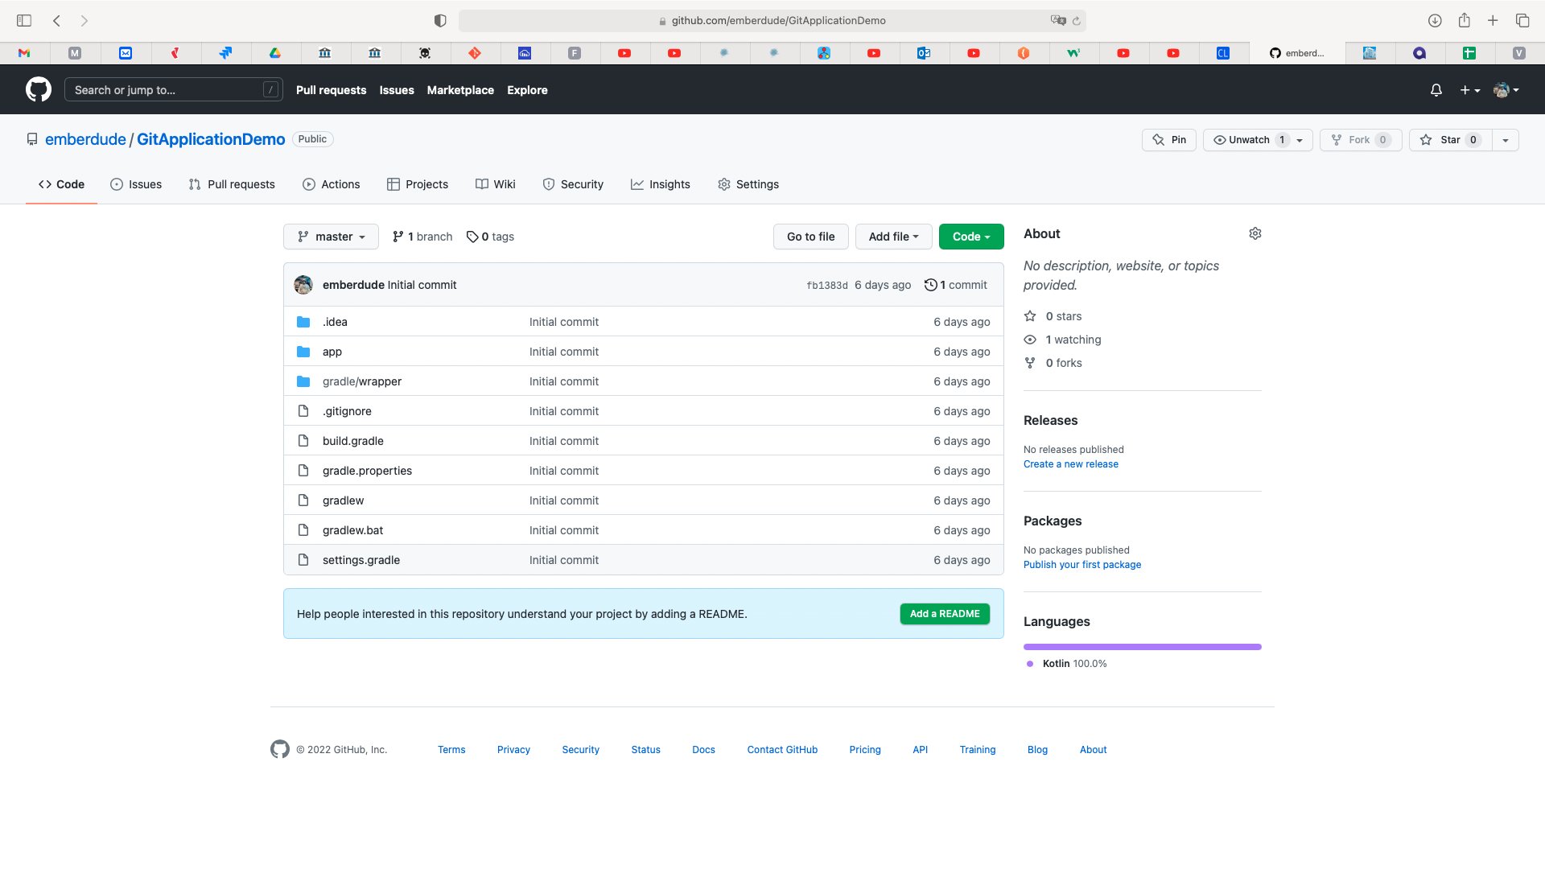

VSCode installed and Thunder Client also too